

**Procedure and Code to Reconstruct the Project Set-up**

* First of all collect all the poles and set them at equal distances.

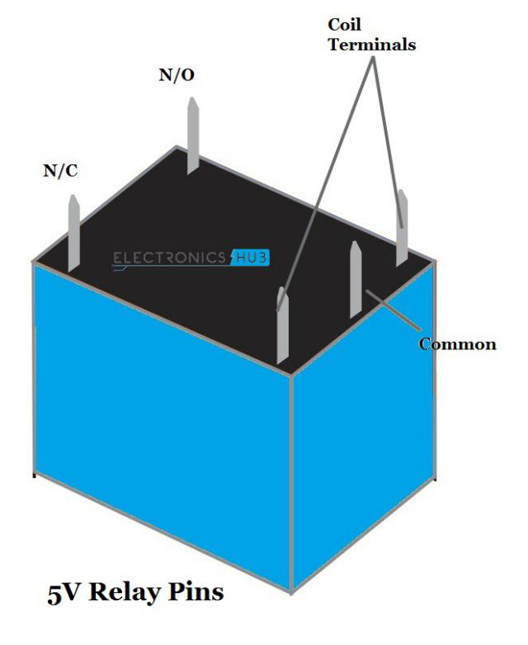

* Bring the main supply of the bulb near the Arduino and connect them with relay as per given instruction.
* After connecting the relay, bring the Arduino and connect it with relay with the help of jumping wires according To the code given below.
* Set the Vcc and Ground on the line shaped breadboard.
* Bring the Ultrasonic Sensors and connect them at each pole with the help of breadboard and connecting wires to the Arduino according to the code given below.
* Connect all the parts to the Arduino very carefully.
* Check all the connections made with the Arduino and upload the code to the Arduino successfully, keeping the numbers of all the bulbs in the mind.
* Now start testing and debugging. If the Ultra sonic sensors do not work properly, check all the connections made with it and fix them tightly.
* For any query contact : [kishor.sarswat.18cse@bmu.edu.in](mailto:kishor.sarswat.18cse@bmu.edu.in)

[anant.kaul.18cse@bmu.edu.in](mailto:Anant.kaul.18cse@bmu.edu.in)

* The Given code is advised to be used on **Arduino UNO**.



int echo=8;

int trigg=11;

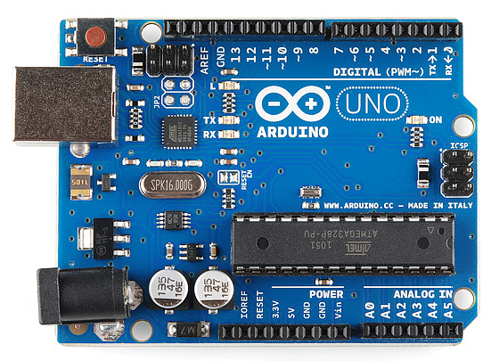int echo2=2;

int trigg2=4;

int echo3=3;

int trigg3=5;

int echo4=10;

int trigg4=9;

int relay1=6;

int relay2=7;

int relay3=12;

int relay4=13;

void setup() {

Serial.begin(9600);

pinMode(echo,INPUT);

pinMode(trigg,OUTPUT);

pinMode(echo2,INPUT);

pinMode(trigg2,OUTPUT);

pinMode(echo3,INPUT);

pinMode(trigg3,OUTPUT);

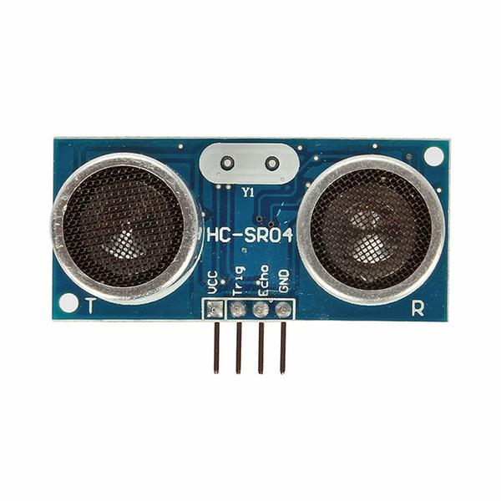 pinMode(echo4,INPUT);

pinMode(trigg4,OUTPUT);

pinMode(relay1,OUTPUT);

pinMode(relay2,OUTPUT);

pinMode(relay3,OUTPUT);

pinMode(relay4,OUTPUT);

}

void loop()

{

digitalWrite(trigg,LOW);

delayMicroseconds(2);

digitalWrite(trigg,HIGH);

delayMicroseconds(10);

digitalWrite(trigg,LOW);

float dur=pulseIn(echo,1);

dur=dur/2;

float dis=0.034529*dur;

Serial.print("DISTANCE= ");

Serial.println(dis);

if (dis<100)

{

digitalWrite(relay1,LOW);

digitalWrite(relay2,LOW);

delay(1000);

}else

{digitalWrite(relay1,HIGH);

digitalWrite(relay2,HIGH);

}

delay(100);

digitalWrite(trigg2,LOW);

delayMicroseconds(2);

digitalWrite(trigg2,HIGH);

delayMicroseconds(10);

digitalWrite(trigg2,LOW);

float dur2=pulseIn(echo2,1);

dur2=dur2/2;

float dis2=0.034529*dur2;

Serial.print("DISTANCE2= ");

Serial.println(dis2);

if (dis2<100)

{

digitalWrite(relay2,LOW);

digitalWrite(relay3,LOW);

delay(1000);

}

else

{digitalWrite(relay2,HIGH);

digitalWrite(relay3,HIGH);

}

delay(100);

digitalWrite(trigg3,LOW);

delayMicroseconds(2);

digitalWrite(trigg3,HIGH);

delayMicroseconds(10);

digitalWrite(trigg3,LOW);

float dur3=pulseIn(echo3,1);

dur3=dur3/2;

float dis3=0.034529*dur3;

Serial.print("DISTANCE3= ");

Serial.println(dis3);

if (dis3<100)

{

digitalWrite(relay3,LOW);

digitalWrite(relay4,LOW);

delay(1000);

}

else

{digitalWrite(relay3,HIGH);

digitalWrite(relay4,HIGH);

}

delay(100);

digitalWrite(trigg4,LOW);

delayMicroseconds(2);

digitalWrite(trigg4,HIGH);

delayMicroseconds(10);

digitalWrite(trigg4,LOW);

float dur4=pulseIn(echo4,1);

dur4=dur4/2;

float dis4=0.034529*dur4;

Serial.print("DISTANCE4= ");

Serial.println(dis4);

if (dis4<100)

{

digitalWrite(relay4,LOW);

delay(1000);

}else{ digitalWrite(relay4,HIGH);

delay(100);

}

}

* Above Project is made by Team **\*Censored\*** in the direction of **Dr. Surya Prakash.**

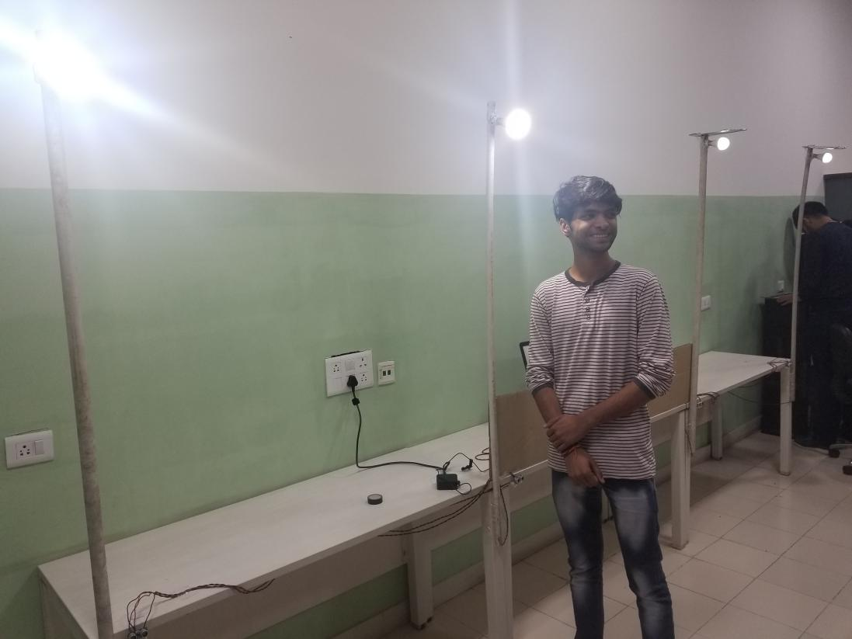

**Team Members:**

* Anant Kaul
* Kishor Sarswat
* Nikunj Jalan
* Mohd. Daim
* Himanshu Jalan
* Sejal Somani